**MUSIC PLAYER USING JAVASCRIPT**

**MUSIC PLAYER USING JAVASCRIPT**

# A MINI PROJECT REPORT

*Submitted by*

Group/ Team No:G-24/T-12

JIYA,2210990463

JIYA GABA,2210990464

JOEL MATTHEW,2210990465

JOYASH SOOD,2210990466

***in partial fulfilment for the award of the degree***

***of***

# BACHELEOR OF ENGINEERING

***in***

# COMPUTER SCIENCE & ENGINEERING



**CHITKARA UNIVERSITY**

**CHANDIGARH-PATIALA NATIONAL HIGHWAY RAJPURA (PATIALA) PUNJAB-140401 (INDIA)**

**MAY,2023**

# A MINI PROJECT REPORT

*Submitted by*

Group/ Team No:G-24/T-12

JIYA,2210990463

JIYA GABA,2210990464

JOEL MATTHEW,2210990465

JOYASH SOOD,2210990466

***in partial fulfilment for the award of the degree***

***of***

# BACHELEOR OF ENGINEERING

***in***

# COMPUTER SCIENCE & ENGINEERING



**CHITKARA UNIVERSITY**

**CHANDIGARH-PATIALA NATIONAL HIGHWAY RAJPURA (PATIALA) PUNJAB-140401 (INDIA)**

**MAY,2023**

# ABSTRACT

This research sheet describes the development and implementation of a word counter tool using CSS, HTML, and JavaScript. The tool is designed to allow users to input text and count the number of words in that text, with a focus on simplicity, user-friendliness, and ease of use. The user interface is created using HTML and CSS, with a clean and simple design that allows users to quickly and easily input text and view the word count. The design is optimized for readability and ease of use, with clear instructions and visual cues to guide the user. The functionality of the word counter is implemented using JavaScript, with a focus on efficiency and accuracy. The JavaScript code uses regular expressions to identify words in the input text, and then counts the number of matches to determine the total word count. The code is designed to handle a wide range of input types and formats, including text with punctuation, special characters, and line breaks. The study involved asking participants to use the tool to count the number of words in a variety of text samples, and then providing feedback on their experience. The results of the study showed that the tool was highly effective at accurately counting words in a range of text formats, and that participants found the tool to be highly user-friendly and intuitive. Overall, this research sheet demonstrates the effectiveness of using CSS, HTML, and JavaScript to create a simple and user-friendly word counter tool. The tool has a wide range of potential applications, including for writers, editors, and students who need to keep track of the number of words in their writing. Future research could focus on enhancing the tool with additional features, such as the ability to count words in specific sections of a text, or to track changes in word count over time. The following table offers a suggested structure and approximate word counts for dissertations, relative to the degree being pursued. This is designed to be altered according to the needs of the researcher, and the stipulations of their supervisor and institution. All dissertations are different, and your supervisor is the best person to talk to about your specific institutional, school, or college requirements, which may vary quite significantly. Creating your own outline through discussion with your supervisor gives you both a sense of where you are in the process and what needs to be done, whilst also functioning as a reference point when completing smaller intermediary targets. The examples below illustrate a general principle of successful research espoused by this book: a larger project becomes much more manageable when broken down into smaller, clearly defined sections.

## TABLE OF CONTENTS

|  |  |  |
| --- | --- | --- |
| S.no | Section | Page |
| 1. | INTRODUCTION | 4 |
| 2. | PROBLEM STATEMENT | 5 |
| 3. | TECHNICAL DETAILS | 6 |
| 4. | KEY FEATURES | 7 |
| 5. | PROJECT ADVANTAGES | 8 |
| 6. | CODE AND ITS OUTPUT  EXPLAINATION | 9 |
| 7. | CONCLUSION AND FUTURE SCOPE | 14 |
| 8. | LIST OF  REFERENCES | 15 |

# INTRODUCTION

The Music Player project involves the creation of a digital countdown timer using HTML, CSS, and JavaScript. The purpose of the project is to create a user-friendly interface that allows users to play, pause and select songs with the help of buttons according to your requirement as well as set up songs

Music player offers a range of features, such as the ability to create and manage playlists, equalizer controls, and the option to download and stream music,allowing users to access a vast library of songs without having to purchase individual tracks.

Music players can be found on many different platforms, including desktop operating systems like Windows and MacOS, as well as mobile platforms like iOS and Android. They are widely used for personal entertainment, as well as for professional purposes, such as in radio broadcasting or music production.

Overall, music players have become an essential tool for many people who love music, as they provide a convenient and customizable way to listen to their favourite tracks and discover new music.

# PROBLEM STATEMENT

Even though we have music player in our androids yet we require online streaming of songs? Why?

Problem:

1. Downloading each song can be pretty space consuming.
2. Creating albums according to our song requirements is time consuming.
3. Song range is limited.
4. Downloading songs can lead to virus threats.
5. Playlists created by user1 cannot be shared directly to some other user.
6. We can’t find artists of our favorite genre
7. Playlist is not up to date.
8. Song management is not smooth

# TECHNICAL DETAILS

**HTML (Hypertext Markup Language)** is a markup language used for creating web pages. It provides the structure and content of a web page, including headings, paragraphs, images, and links. In the project, HTML was used to create the layout of the countdown timer, including the placement and styling of the various elements such as the input fields and the countdown display.

**CSS (Cascading Style Sheets)** is a style sheet language used for describing the presentation of a web page, including the layout, color, and font of various elements. In the project, CSS was used to style the countdown timer, including the font, color, and size of the countdown display, as well as the positioning and layout of the input fields and buttons.

**AUDIO OUTPUTS**: Music players use audio outputs such as speakers, headphones, and digital audio outputs to play back audio.

**STORAGE DEVICES**: Music players can store music files on various types of storage devices such as hard drives, solid-state drives, and memory cards.

**WIRELESS TECHNOLOGIES**: Music players can connect to other devices wirelessly using technologies such as Bluetooth and Wi-Fi.

# KEY FEATURES

* Play, pause, and stop buttons: These buttons allow the user to control the playback of the music.
* Progress bar: A progress bar indicates the current position of the music playback and how much time has elapsed.
* Volume control: A volume slider allows the user to adjust the volume of the music.
* Playlist: A playlist allows the user to select which songs they want to play.
* Album artwork display: The music player can display the album artwork of the currently playing song.
* Crossfade: Crossfade is the ability to fade out one song while fading in the next song, creating a smooth transition between the two.
* Customizable themes: Users can change the appearance of the music player by choosing different themes or skins.

# PROJECT ADVANTAGES

The Music Player project offers several advantages for both web developers and users, including:

There are many advantages to developing a music player, such as:

1. Access to a large user base: Music is a universal language that has a massive and diverse audience. Developing a music player provides an opportunity to reach a broad range of users, from casual music listeners to professional musicians and music producers.

2. Revenue opportunities: A music player can offer various revenue streams, including advertising, subscription models, in-app purchases, and partnerships with music labels and streaming services. This can provide a sustainable business model and generate revenue for both the music player developers and content creators.

3. Personalization and user engagement: Music is a highly personal experience, and a music player can provide opportunities to personalize the user experience through features such as personalized recommendations, curated playlists, and social sharing. This can increase user engagement and loyalty, as well as create a sense of community among music lovers.

4. Integration with other services: A music player can be integrated with other services, such as social media platforms, concert ticket vendors, and merchandise retailers, creating additional revenue streams and opportunities for user engagement.

5. Innovation and differentiation: The music player market is highly competitive, and developing a music player offers an opportunity to innovate and differentiate from competitors. This can include unique features, user interfaces, and branding strategies that set the music player apart from other options on the market.

Overall, developing a music player can provide a range of advantages, from reaching a large user base and generating revenue to personalizing the user experience and innovating in a competitive market.

# CODE AND ITS OUTPUT EXPLAINATION

**HTML CODE:**

HTML (Hypertext Markup Language) is a markup language used for creating web pages. It provides the structurend content of a web page, including headings, paragraphs, images, and links. In the project, HTML was used to create the layout of the countdown timer, including the placement and styling of the various elements such as the input fields and the countdown display.

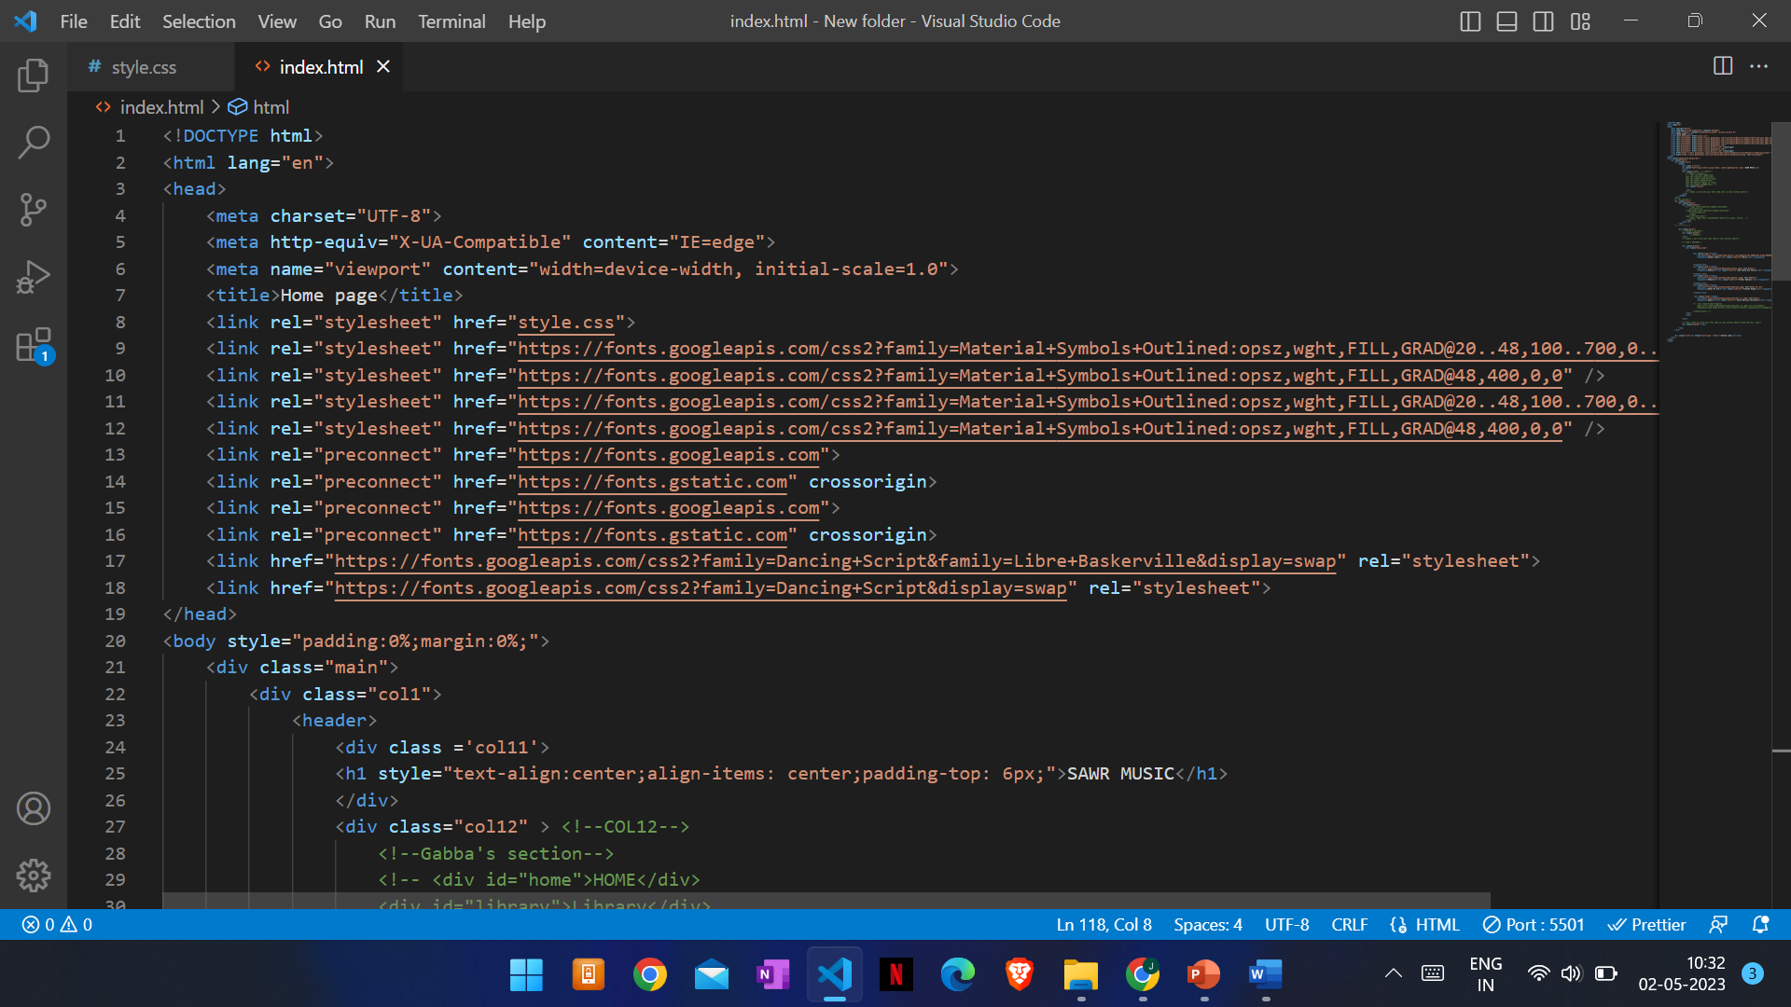

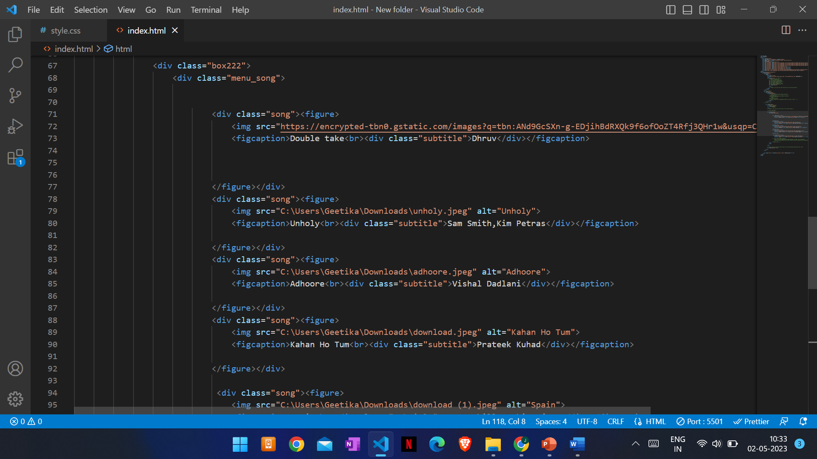

**CSS CODE:**

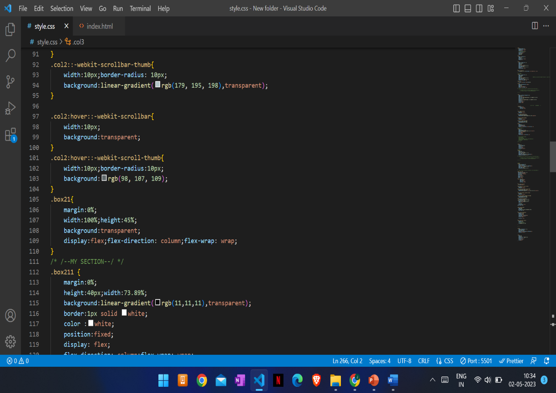For styling the webpage we have used CSS. In CSS, firstly we have made universal style and added margin, padding and bot sizing. Then we styled a contain. In container, we’ve have used flex property for aligning the elements in centre, background colour, text colour and adjusted the width and height as per the requirement. In text area, we styled the font by using font size and font family. In output box division we added flex property space between and adjusted the width and height as per our need. In this code, we define the styling for the text area where users will enter their text, and the div element where the word count will be displayed. Overall, CSS is an essential tool in enhancing the appearance and functionality of a word counter and can make it more user-friendly and engaging for your audience.

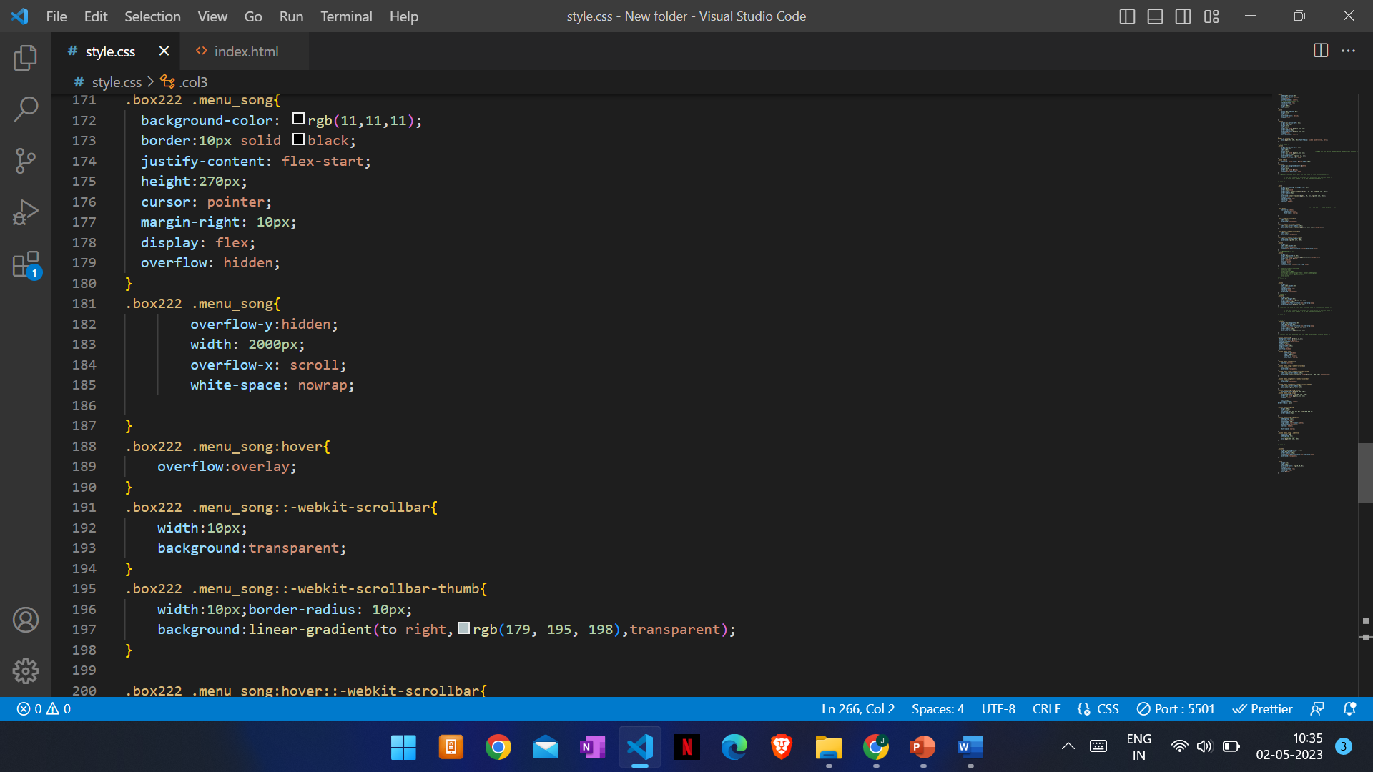

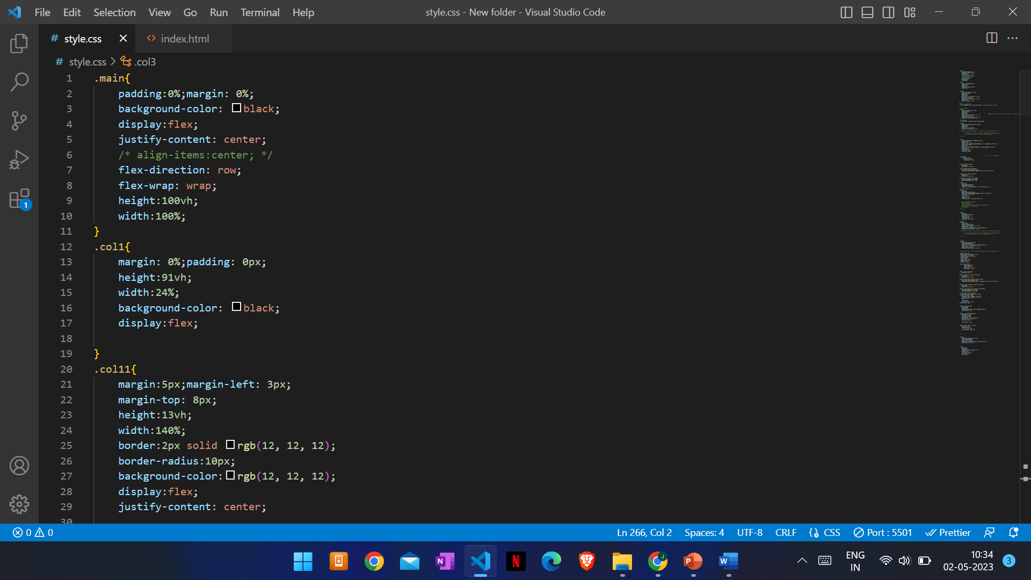

**JAVA CODE:**

JavaScript (JS) is a lightweight, interpreted or just-in-time compiled programming language with first-class functions. It is a multi-paradigm, single-threaded, dynamic language, supporting object-oriented, imperative, and declarative (e.g. functional programming) styles.

JavaScript is a powerful tool that can be used to create engaging and interactive web experiences. If you are interested in web development, JavaScript is a language that you should definitely learn.

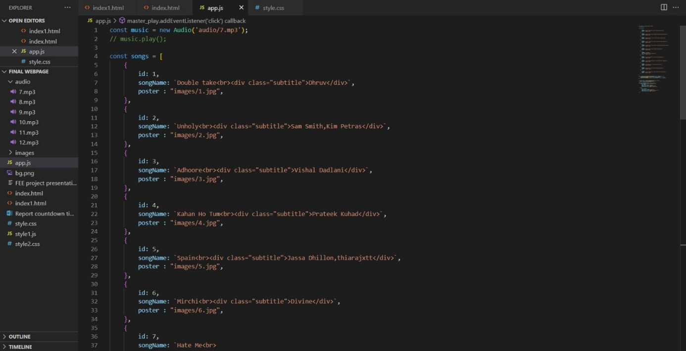

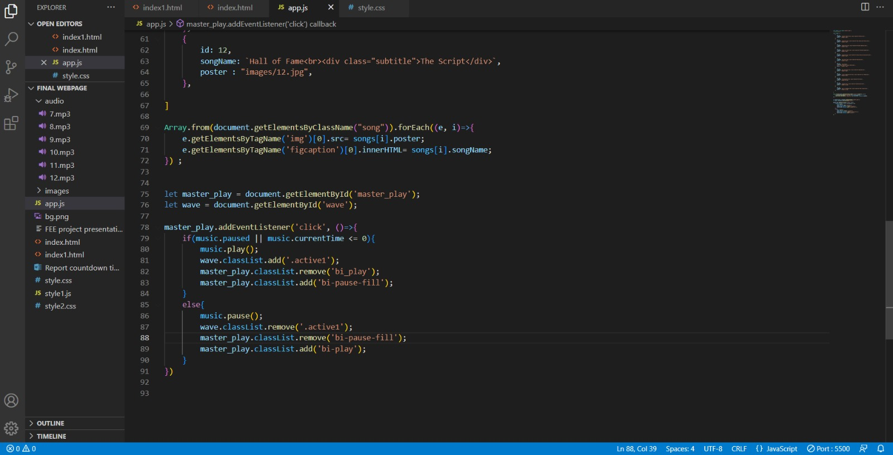

**Here is the output of the codes:**

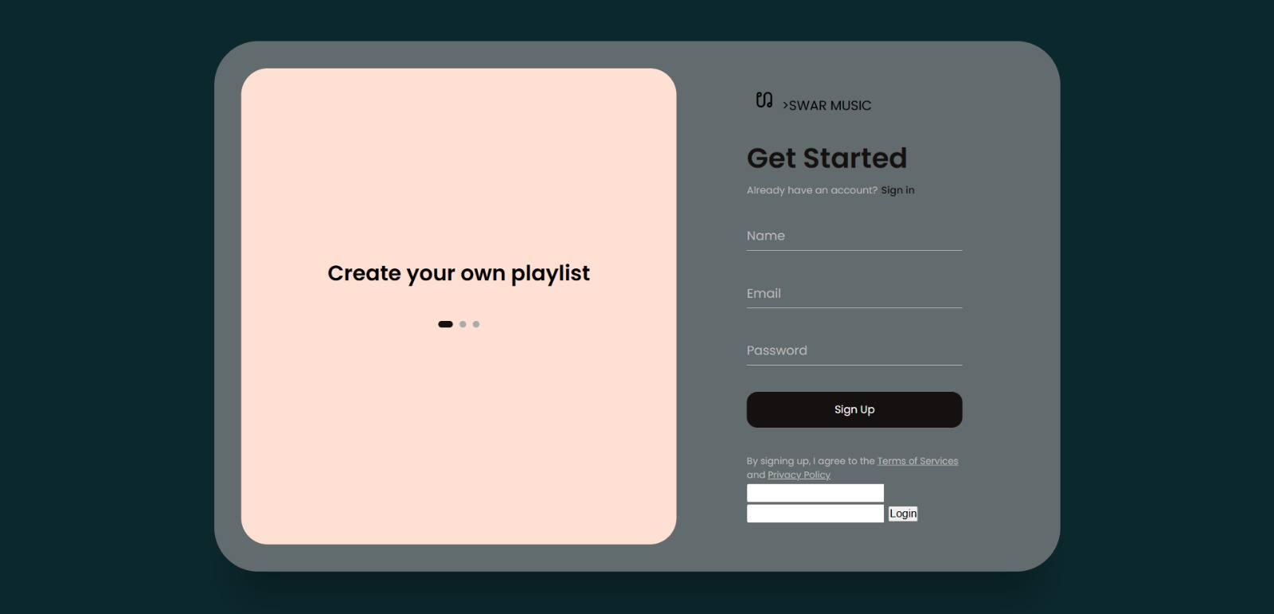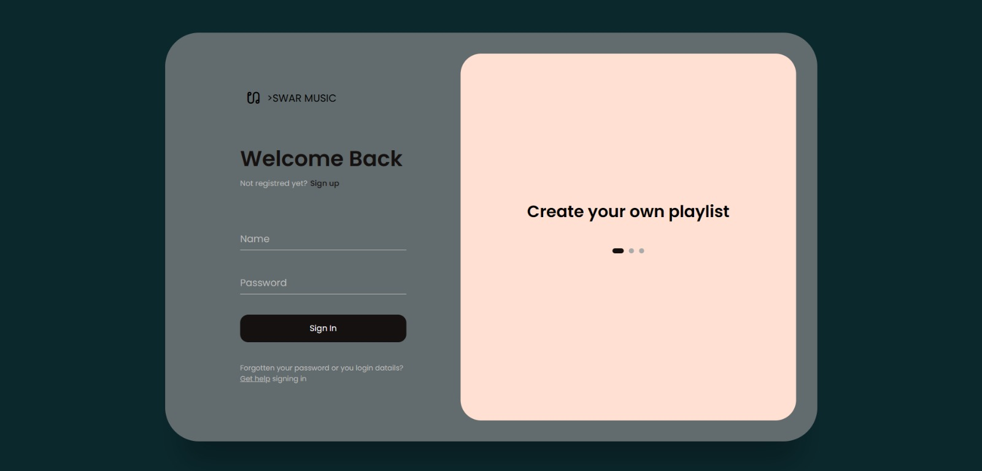

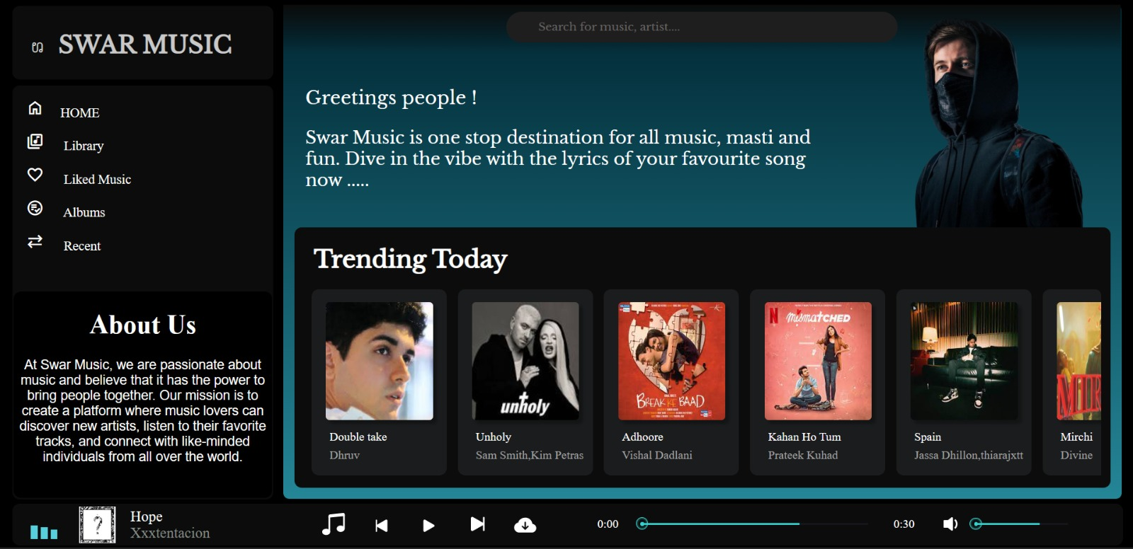

# CONCLUSIONS AND FUTURE SCOPE

In conclusion, developing a music player can provide significant advantages, such as a large user base, revenue opportunities, personalization, integration with other services, and innovation. As the music industry continues to evolve and grow, music players will continue to play an essential role in how people consume and interact with music.

In terms of future scope, there are several exciting opportunities for music players, including:

1. Advanced AI and machine learning algorithms for better recommendations and personalized playlists

2. Integration with virtual and augmented reality technologies for immersive music experiences

3. Increased focus on social and community features, allowing users to connect and collaborate with other music lovers

4. Expansion into emerging markets, such as Asia and Africa, where music consumption is rapidly growing

5. Integration with emerging technologies, such as blockchain and decentralized platforms, to increase transparency and control over music ownership and distribution.

Overall, the future of music players looks promising, with many exciting opportunities for innovation and growth. Music players will continue to evolve and adapt to meet the changing needs and preferences of music lovers around the world

**LIST OF REFERENCES**

References of this project have been taken from the below mentioned sites-

* <https://music.youtube.com/>
* <https://open.spotify.com/>
* <https://www.jiosaavn.com/>
* <https://music.apple.com/us/browse>